SARA LEE
Chalk Lines
Drawings from the South Downs

Rabley Gallery a t 1 5 5 A G a l l e r y, L o n d o n S E 2 2
April 24th - May 3rd 2026
Private View Thursday 23 April 6 – 8pm

Public Opening Hours - Free
Thursday – Saturday 11am – 6pm
Sunday 11am – 3pm

EVENT – Artists Talk: Saturday 25th April – 2.30 – 3.30pm Free, please book as places are limited – LINK TO BOOK
EVENT – Gathering with the Artist: Saturday 25th April – 4pm – 6pm

155A Lordship Lane, East Dulwich London SE22 8HX

Parking available in surrounding residential streets
Nearest station: North Dulwich, East Dulwich, Denmark Hill
Buses: 176, 185, 40, P13
View on Google Maps
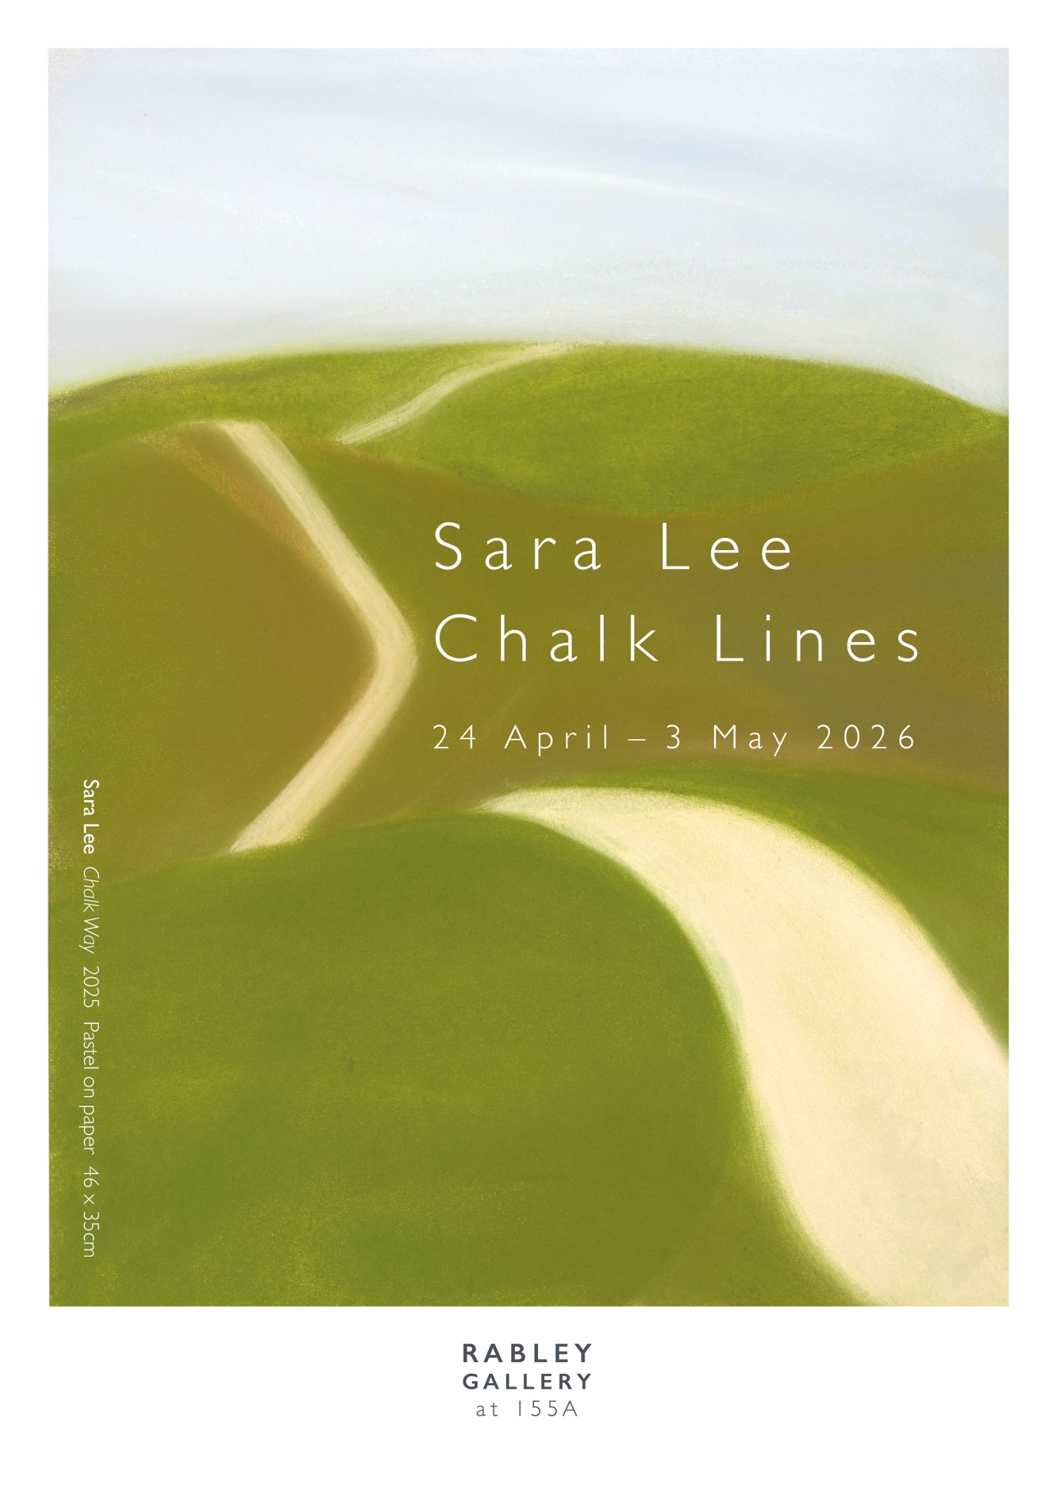
From ancient paths Sara Lee’s ‘Chalk Lines’ pastel drawings take us towards the changing light on the horizon. As an artist she immerses herself in long walks and working from the land. This series of new drawings is made in response to Lee walking the 100 miles of the South Downs Way in Sussex. Alongside the drawings there will be the artists’ field notes and sketchbooks and a specially commissioned film. Lee evokes aesthetic movements of the past, with considerations of ‘Romanticism’ and ‘The Sublime’ and considers their contemporary relevance. Winner of the South Downs Open Prize, her awarded solo exhibition is touring from Petersfield Museum and Gallery to 155A in London with Rabley Gallery.

Catalogue Available £12 inc. P&P (UK)
Sara Lee Chalk Lines
Softback, Fully-illustrated in colour, 170 x 240mm, 44pp Published by Petersfield Museum 2026. With texts by Louise Weller, Curator, Petersfield Museum and Gallery, Sara Lee and Meryl Ainslie, Director of Rabley Gallery
ISBN 978-1-919371-0-6

All works are for sale. Request a price list
Contact – Meryl Ainslie meryl@rableygallery.com Tel. +44(0)7967545136

For Sara Lee creating her pastels and prints involves long walks in landscape and working from the land. These are not journeys to be conquered and documented, they are space and time inhabited - being in the environment. Lee holds us, suspended within the time spent, the landscape encountered, the walk made and her thoughts considered. She evokes aesthetic movements of the past, with considerations of ‘Romanticism’ and ‘The Sublime’ and their contemporary relevance.
Each journey is followed be an extended period of making in her London studio, predominantly in pastel drawing and printmaking. The subtlety of her pastel drawings is perfectly echoed by the graphically stripped back Japanese woodcut technique in the Ukiyo – e tradition that she favours.
Far from being overwhelmed by the power of nature, Lee invites the viewer to pause and contemplate the importance of landscape and our profound relationship with it. This is especially apposite at this time of ominous environmental change. Often working with changing or dramatic light: at dawn, dusk or with an approaching storm, the long distance is a constant thread and compelling focus.
In collaboration with Rabley Gallery, our relationship began with a year- long residency in the Wiltshire Downs on the Ainslie family farm associated with the gallery (2013). She would visit each month for a few days working with a landscape similar in geology to the beautiful South Downs. This was followed by her solo exhibition ‘Ley of the Land’ (2014)
Numerous residencies have informed the development of her work including those in Venice (2015), and Alayrac, France, (2017). Investigating numerous coastal pathways has led to her extensive series Beckoning Lines and the exhibition To the Edge of Evening (2024). It is one of this recent series that was awarded the ‘South Downs Art Prize’ and initiated this exhibition in Petersfield Museum’s contemporary gallery.
Her work is held in public and private collections internationally, including the Victoria & Albert Museum; Pallant House Gallery; Swindon Museum and Gallery; Victoria Art Gallery, Bath; Otter Gallery; University of Chichester Collection, UK; United Therapeutics Art Collection, USA; Tama University Collection, Tokyo, Japan.
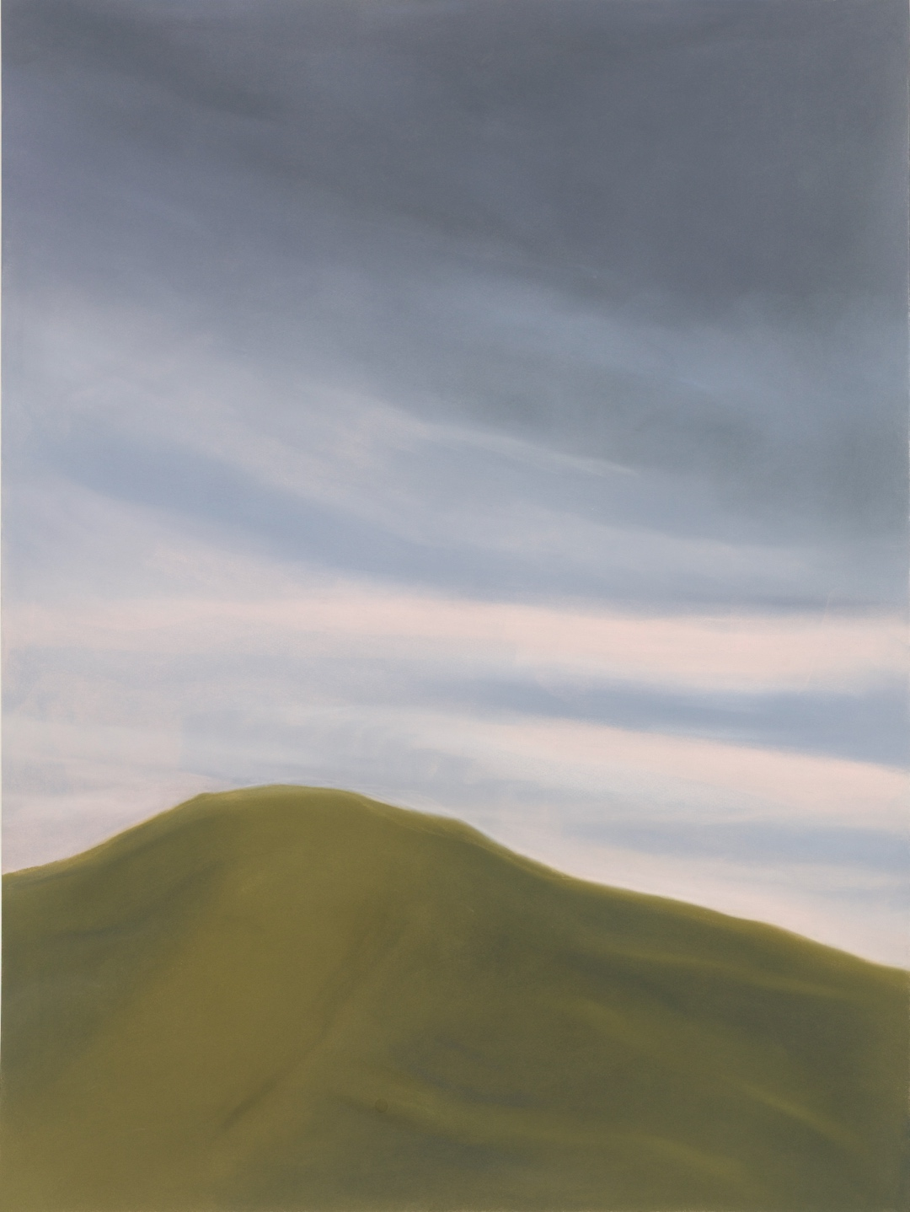
Sara Lee, Dream Time, 2025, Pastel on paper, 102 x 76cm

